Brief Bio of Josefa E. Bethea Wall

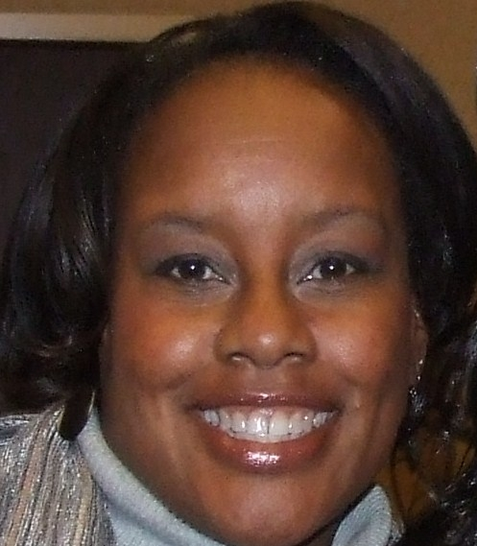
Josefa E. Bethea Wall, a lifelong Methodist, is a native of North Carolina. She is the daughter of the late Bishop Joseph B. and Shirley C. Bethea. Motivated to be a servant leader, she has served the United Methodist Church in a variety of capacities. Currently, she is Director of Planned Giving for Africa University. She has served on the Advisory Development Committee for the university for over 20 years. She served as the secretary for the Board of Directors for the General Board of Higher Education and Ministry and was a member of the Loans & Scholarship Committee for one quadrennium. She continues to support the UM-related Black College Fund, for which she served as an ambassador in 1984 and 1985. Josefa has been a delegate to the World Methodist Conferences held in Waikiki, Hawaii, Nairobi Kenya, Rio de Janeiro, Brazil Brighton, England and Durban, South Africa. In 2011, she was named a member of the World Methodist Council. She has also served the church in her role as a freelance writer for United Methodist Communications.

Mrs. Bethea Wall has over 30 years of experience in community-building, grants management and higher education. She has worked as Community Fund Grants Manager for United Way of Central New Mexico, State Coordinator for Citizen Schools-New Mexico, Director for the Albuquerque Bernalillo County Community School Partnership, Program Officer for the Moses Cone ~ Wesley Long Community Health Foundation and Community Initiatives Specialist for United Way of Greater Greensboro. In each of her roles, she has focused on advancing sustainable community development by cultivating strategic partnerships, guiding the mobilization of nonprofit organizations toward collective impact and engaging stakeholders in efforts to improve the quality of life for all.

Mrs. Bethea Wall received her baccalaureate from Bennett College in Greensboro, North Carolina, one of eleven historically black colleges supported by the United Methodist Church.
She has a Master of Public Administration degree with a concentration in Nonprofit Management from the University of North Carolina at Greensboro; a Nonprofit Management Certificate from Duke University; Process Management and Nonprofit Management certificates from the University of New Mexico and an Executive Certificate in Religious Fundraising from Lake Institute.

Josefa is married to her childhood sweetheart, Bryon Wall. Currently, Bryon is General Manager with Brookfield Properties.

